#### Assignment 01 Git and Github

**Name: Pratik Satham**

Git Init NewBranch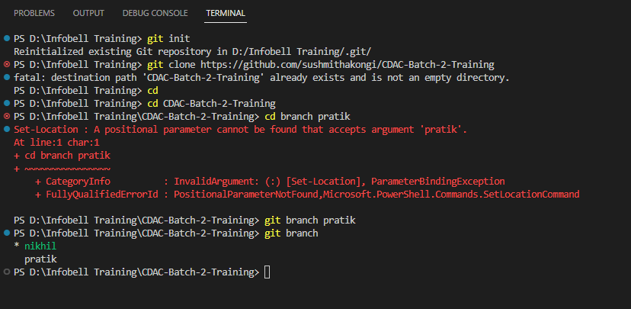

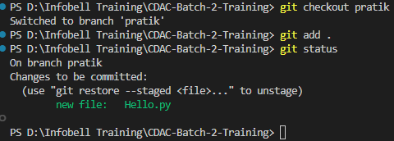

Git Commit

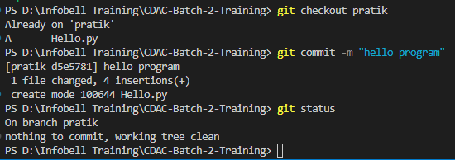

Git Push

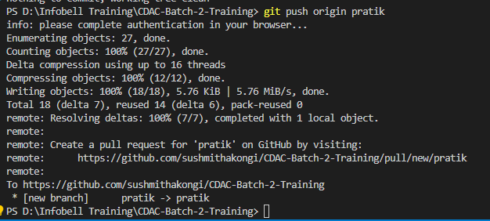

**Second Problem ( For revision purpose only )**

Sample code :

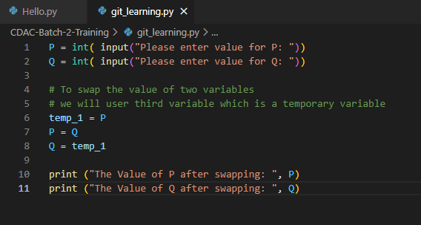

Code Output and Git Cloning :

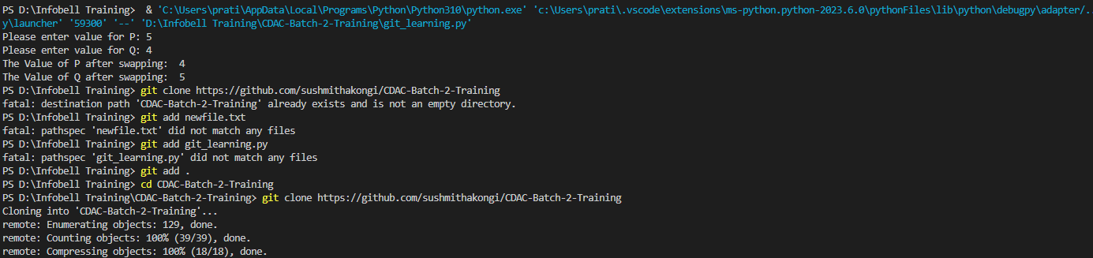

Created a new Branch and using git checkout , We are on **pratik** named branch.

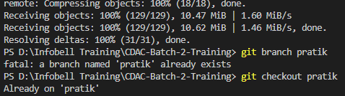

Adding the python file using ***git clone and git add commands :***

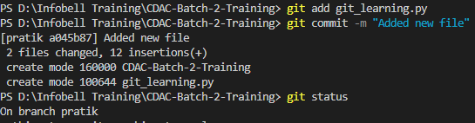

Pulling the existing data Using ***git pull origin <branch name>:***

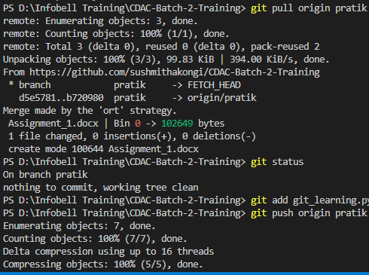

**Finally again added new file for merging purpose and pushed to the repository :**

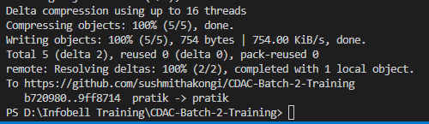

# ab 5







